**ABHISHEK SHARMA**

**CS 2ND YEAR**

**SECTION : “I”**

**ROLL NO.: 01**

**ENROLLMENT NO.: 12019009001127**

**PRE PLACEMENT CLASS**

**ASSIGNMENT SOLUTION IN C LANGUAGE**

**DATE : 12.11.2020**

**Q1. Arrays and find the no. of elements in that Array.**

**Code:**

#include<stdio.h>

int main(){

int test,i,j,g,k;

int count;

int m=0;

int tmp;

char arr[100];

int repeat = 0;

scanf("%d",&test);

for (i=0;i<test;i++){

scanf("%d",&count);

for (j=0;j<count;j++){

scanf("%d",&arr[j]);

}

for(i=0; i<count; i++)

{

for(j=i+1; j<count; j++)

{

if(arr[j] <arr[i])

{

tmp = arr[i];

arr[i] = arr[j];

arr[j] = tmp;

}

}

}

for (g=0;g<count;g++){

if (repeat!=arr[g]){

for (k=0;k<count;k++){

if (arr[g]==arr[k]){

m = m+1;

}

}

repeat = arr[g];

printf ("%d %d\n",arr[g],m);

m = 0;

}

}

}

return 0;

}

**Output :**

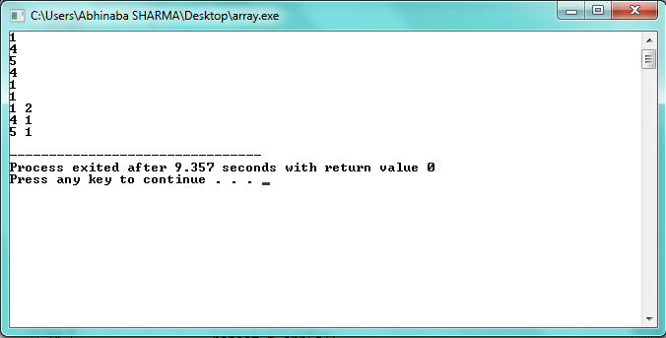

**Q2. Sayan and his race event.**

**Code:**

#include<stdio.h>

int main(){

int test,i;

int j;

int k;

char arr[5];

int t,s,p,l,final,c;

scanf ("%d",&test);

for (i=0;i<test;i++){

for(j=0;j<2;j++){

scanf("%d",&arr[j]);

}

s = 0;

p = 0;

l = 0;

for (k=1;k<100;k++){

c = arr[1]*k;

if (c<arr[0]){

t = 2*c;

s = s + t;

}

else if (c==arr[0]){

p = 3*arr[0];

break;

}

else if (c>arr[0]){

l = arr[0];

break;

}

}

final = s + p + l;

printf("%d\n",final);

}

}

**Output :**

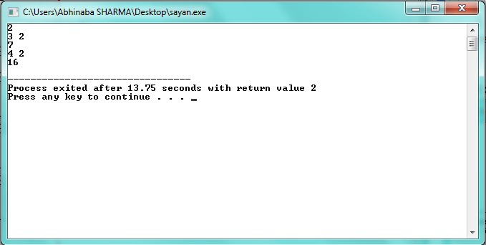

**Q3. Chef and Queries problem**

**Code :**

#include <stdio.h>

int main(){

int test;

int i,j,sum=0,day,ans,work,k=0;

char arr[100];

scanf ("%d",&test);

for(i=0;i<test;i++){

scanf ("%d %d",&day,&ans);

sum = 0;

for (j=0;j<day;j++){

scanf ("%d",&arr[j]);

sum = sum + arr[j];

}

k=0;

while (1>0){

work = sum - ans;

sum = work;

if (work<0){

printf("%d\n",k+1);

break;

}

k = k + 1;

}

}

}

**Output :**

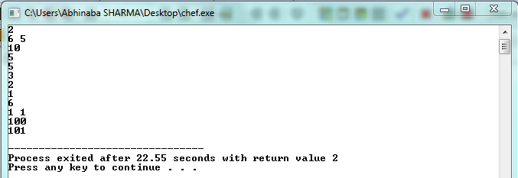

**Q4. Covid Run problem**

**Code:**

#include<stdio.h>

#include<stdlib.h>

void main(){

int t,n,k,x,y,i;

int *arr;

scanf("%d",&t);

while(t>0){

t--;

scanf("%d %d %d %d",&n,&k,&x,&y);

arr=(int *)malloc(n*sizeof(int));

i=x;

while(1){

i=(i+k)%n;

if(x==y || i==y){

printf("YES\n");

break;

}

else if(i==x){

printf("NO\n");

//exit;

break;

}

}

}

}

**Output:**

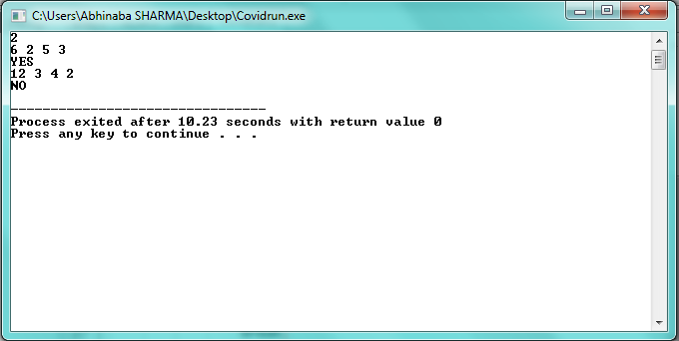

**Abhishek Sharma**

**CS 2nd year : Section : I : Roll no. 01**